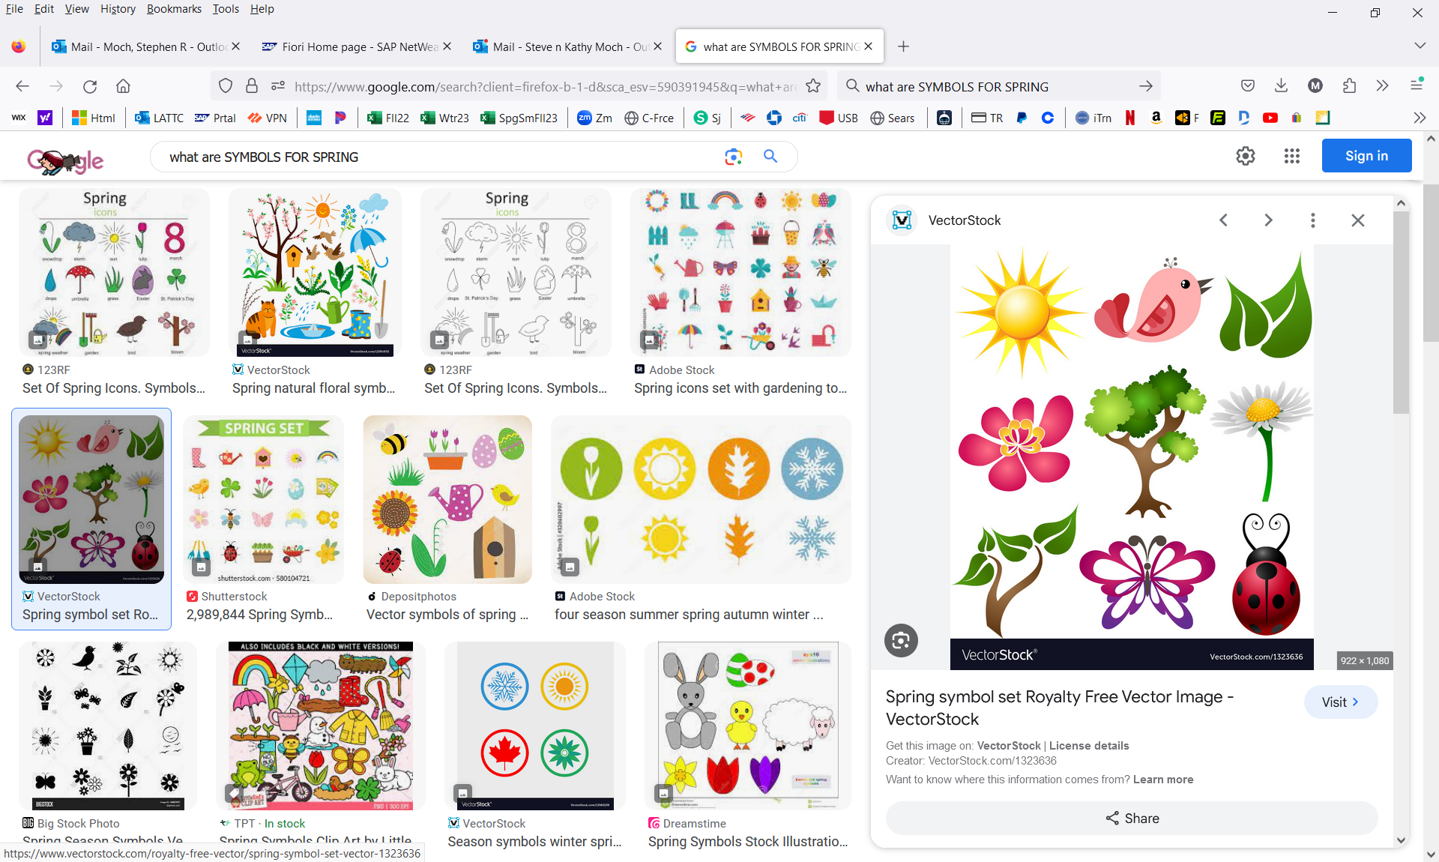

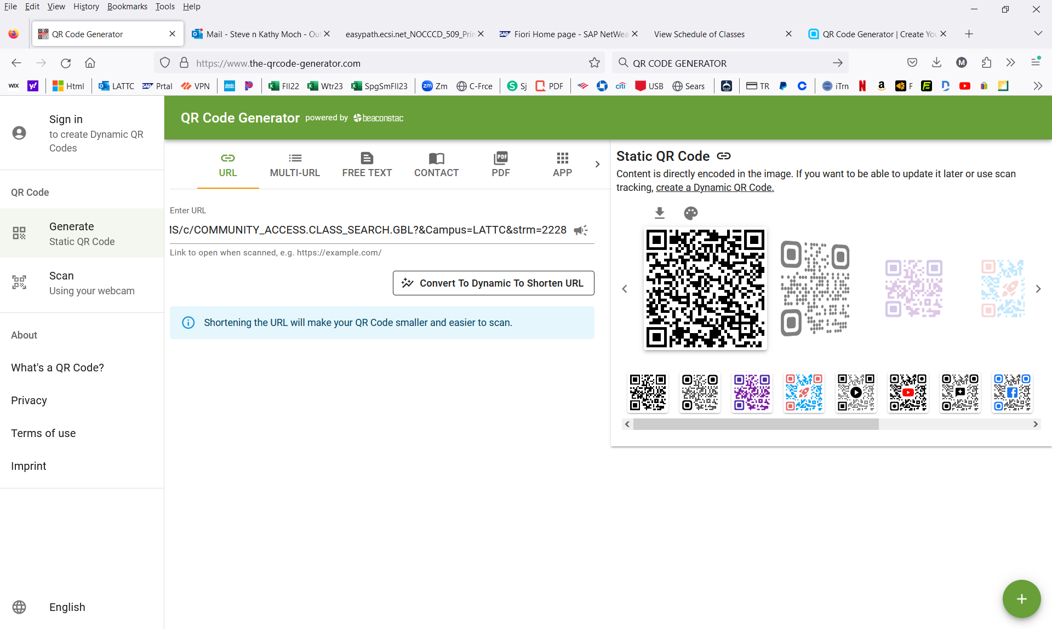
ADULT EDUCATION SPRING 2024 CLASS SCHEDULE
CLASS DATES: FEBRUARY 5, 2024 – JUNE 3, 2024
SIGN UP FOR FREE ESL AND GED CLASSES – NEW & CONTINUING STUDENTS
ESL CLASS OFFERINGS
Catalog Number | Mode | Class # | Start Date |  | End Date |  | Start Time |  | End Time |  | Asynch | AM/PM |  | MTG Days |  | Location |  | Instructor
ESL NC-001CE | LEC | 26784 | 2/12/2024 |  | 3/27/2024 |  | 8:30 AM |  | 11:30 AM |  | N/A | MORNING |  | T TH |  | D3-109A-1 |  | CROTEAU
ESL NC-001CE | LEC | 27685 | 4/8/2024 |  | 6/3/2024 |  | 8:30 AM |  | 11:30 AM |  | N/A | MORNING |  | T TH |  | D3-109A-1 |  | CROTEAU
Catalog Number | Mode | Class # | Start Date |  | End Date |  | Start Time |  | End Time |  | Asynch | AM/PM |  | MTG Days |  | Location |  | Instructor
ESL NC-006CE | LEC | 14485 | 2/5/2024 |  | 6/3/2024 |  | 8:30 AM |  | 11:45 AM |  | NA | MORNING |  | M W |  | C2-205 |  | SHABAZZ
ESL NC-006CE | LEC | 14486 | 2/5/2024 |  | 6/3/2024 |  | 6:00 PM |  | 9:15 PM |  | NA | EVENING |  | M W |  | F5-212 |  | EBERSOLD
ESL NC-006CE | LEC | 16984 | 2/5/2024 |  | 6/3/2024 |  | 6:00 PM |  | 9:15 PM |  | NA | EVENING |  | M W |  | ONLINE |  | ELGUDIN
ESL NC-006CE | LEC | 22027 | 2/5/2024 |  | 6/3/2024 |  | 9:00 AM |  | 11:15 AM |  | NA | MORNING |  | T TH |  | OFF CAMP |  | PORTER
ESL NC-006CE | LEC | 23047 | 4/8/2024 |  | 6/3/2024 |  | 6:00 PM |  | 9:30 PM |  | 2H 30M | EVENING |  | T TH |  | F5-413 |  | ALAIMALO
Catalog Number | Mode | Class # | Start Date |  | End Date |  | Start Time |  | End Time |  | Asynch | AM/PM |  | MTG Days |  | Location |  | Instructor
ESL NC-050CE | LEC | 19040 | 4/8/2024 |  | 6/3/2024 |  | 12:00 PM |  | 2:30 PM |  | 2H | AFTERNOON |  | M W |  | D3-109N |  | SHABAZZ
ESL NC-050CE | LEC | 21255 | 2/5/2024 |  | 3/27/2024 |  | 12:00 PM |  | 2:15 PM |  | 2H 10M | AFTERNOON |  | M W |  | F5-210 |  | SHABAZZ
ESL NC-050CE | LEC | 21256 | 2/5/2024 |  | 6/3/2024 |  | 8:30 AM |  | 12:05 PM |  | NA | MORNING |  | F |  | ONLINE |  | JANVELYAN
ESL NC-050CE | LEC | 22028 | 2/5/2024 |  | 6/3/2024 |  | 8:30 AM |  | 10:05 AM |  | NA | MORNING |  | M & F |  | OFF CAMP |  | KOUZNETSOVA
ESL NC-050CE | LEC | 26571 | 2/5/2024 |  | 6/3/2024 |  | 10:10 AM |  | 11:45 AM |  | NA | MORNING |  | M & F |  | OFF CAMP |  | KOUZNETSOVA
ESL NC-050CE | LEC | 22308 | 2/5/2024 |  | 3/27/2024 |  | 8:30 AM |  | 11:50 AM |  | NA | MORNING |  | M W |  | OFF CAMP |  | CROTEAU
ESL NC-050CE | LEC | 22309 | 4/8/2024 |  | 6/3/2024 |  | 8:30 AM |  | 11:50 AM |  | NA | MORNING |  | M W |  | OFF CAMP |  | CROTEAU
ESL NC-050CE | LEC | 22310 | 2/5/2024 |  | 3/27/2024 |  | 6:00 PM |  | 8:05 PM |  | NA | EVENING |  | T W TH |  | OFF CAMP |  | TSTAFF
ESL NC-050CE | LEC | 22311 | 4/8/2024 |  | 6/3/2024 |  | 6:00 PM |  | 8:05 PM |  | NA | EVENING |  | T W TH |  | OFF CAMP |  | TSTAFF
ESL NC-050CE | LEC | 22576 | 2/17/2024 |  | 6/3/2024 |  | 8:00 AM |  | 11:35 AM |  | NA | MORNING |  | S |  | OFF CAMP |  | CROTEAU
Catalog Number | Mode | Class # | Start Date |  | End Date |  | Start Time |  | End Time |  | Asynch | AM/PM |  | MTG Days |  | Location |  | Instructor
ESL NC-007CE | LEC | 14487 | 2/5/2024 |  | 6/3/2024 |  | 8:30 AM |  | 11:15 AM |  | 1H 5M | MORNING |  | M W |  | F5-208 |  | ALAIMALO
ESL NC-007CE | LEC | 14488 | 2/5/2024 |  | 6/3/2024 |  | 6:00 PM |  | 9:15 PM |  | NA | EVENING |  | T TH |  | F5-212 |  | PORTER
ESL NC-007CE | LEC | 18760 | 2/5/2024 |  | 6/3/2024 |  | 6:00 PM |  | 8:45 PM |  | 1H 5M | EVENING |  | T TH |  | ONLINE |  | BHANDARI
ESL NC-007CE | LEC | 16985 | 2/5/2024 |  | 6/3/2024 |  | 6:00 PM |  | 9:15 PM |  | NA | EVENING |  | M W |  | F5-412 |  | KOUZNETSOVA
ESL NC-007CE | LEC | 16986 | 2/5/2024 |  | 6/3/2024 |  | 6:00 PM |  | 9:15 PM |  | NA | EVENING |  | M W |  | ONLINE |  | KATA
Catalog Number | Mode | Class # | Start Date |  | End Date |  | Start Time |  | End Time |  | Asynch | AM/PM |  | MTG Days |  | Location |  | Instructor
ESL NC-008CE | LEC | 16757 | 2/5/2024 |  | 6/3/2024 |  | 8:30 AM |  | 11:15 AM |  | 1H 5M | MORNING |  | M W |  | F5-208 |  | JAVADYAN
ESL NC-008CE | LEC | 18970 | 2/5/2024 |  | 6/3/2024 |  | 6:00 PM |  | 9:15 PM |  | NA | EVENING |  | M W |  | ONLINE |  | LEVEQUE
ESL CLASSES
Catalog Number | Mode | Class # | Start Date |  | End Date |  | Start Time |  | End Time |  | Asynch | AM/PM |  | MTG Days |  | Location |  | Instructor
ESL NC-009CE | LEC | 18131 | 2/5/2024 |  | 6/3/2024 |  | 8:30 AM |  | 11:15 AM |  | 1H 5M | MORNING |  | T TH |  | ONLINE |  | CAZARES
ESL NC-009CE | LEC | 18132 | 2/5/2024 |  | 6/3/2024 |  | 6:00 PM |  | 9:15 PM |  | NA | EVENING |  | M W |  | ONLINE |  | GIDES
Catalog Number | Mode | Class # | Start Date |  | End Date |  | Start Time |  | End Time |  | Asynch | AM/PM |  | MTG Days |  | Location |  | Instructor
ESL NC-051CE | LEC | 21257 | 2/5/2024 |  | 6/3/2024 |  | 8:30 AM |  | 12:05 PM |  | NA | MORNING |  | F |  | D3-109A-1 |  | GIDES
ESL NC-051CE | LEC | 21259 | 4/8/2024 |  | 6/3/2024 |  | 12:00 PM |  | 2:15 PM |  | 1H 30M | AFTERNOON |  | T TH |  | ONLINE |  | SHABAZZ
ESL NC-051CE | LEC | 21398 | 4/8/2024 |  | 6/3/2024 |  | 6:00 PM |  | 9:10 PM |  | NA | EVENING |  | M W |  | F5-215 |  | PORTER
ESL NC-051CE | LEC | 21397 | 2/5/2024 |  | 3/27/2024 |  | 6:00 PM |  | 9:20 PM |  | NA | EVENING |  | M W |  | F5-215 |  | PORTER
ESL NC-051CE | LEC | 23110 | 2/5/2024 |  | 3/27/2024 |  | 12:00 PM |  | 2:15 PM |  | 2H 10M | AFTERNOON |  | T TH |  | ONLINE |  | SHABAZZ
ESL NC-051CE | LEC | 26786 | 2/5/2024 |  | 3/27/2024 |  | 8:30 AM |  | 11:45 PM |  | NA | MORNING |  | T TH |  | F5-215 |  | SHABAZZ
ESL NC-051CE | LEC | 26787 | 4/8/2024 |  | 6/3/2024 |  | 8:30 AM |  | 11:45 AM |  | NA | MORNING |  | T TH |  | F5-215 |  | SHABAZZ
Catalog Number | Mode | Class # | Start Date |  | End Date |  | Start Time |  | End Time |  | Asynch | AM/PM |  | MTG Days |  | Location |  | Instructor
ESLCVC NC 013CE | LEC | 14746 | 2/5/2024 |  | 3/27/2024 |  | 12:00 PM |  | 3:20 PM |  | NA | AFTERNOON |  | T TH |  | ONLINE |  | TORRES-RIZZIO
LOS ANGELES TRADE TECH COLLEGE | ADULT EDUCATION & NON-CREDIT DEPARTMENT
400 W. WASHINGTON BLVD., LOS ANGELES, CA 90015
OFFICE: D3 BUILDING – ECHO ROOM
VISIT: WWW.LATTC.EDU PH: 213-763-3762
BASIC SKILLS CLASS OFFERINGS - SPRING 24’
Catalog Number | Mode | Class # | Start Date | End Date | Start Time | End Time | MTG Days | Location | Instructor
BSCSKLS 060CE Lev. 2 | LEC | 16994 | 2/5/2024 | 3/27/2024 | 6:00PM | 6:55 PM | T TH | Online | H. MARTINEZ
BSCSKLS 060CE Lev. 2 | LAB | 16995 | 2/5/2024 | 3/27/2024 | 7:00 PM | 9:10 PM | T TH | Online | H. MARTINEZ
BSCSKLS 060CE Lev. 3 | LEC | 16998 | 2/5/2024 | 4/18/2024 | 6:00PM | 6:55 PM | T TH | Online | CAZARES
BSCSKLS 060CE Lev. 3 | LAB | 16999 | 2/5/2024 | 4/18/2024 | 7:00 PM | 8:35 PM | T TH | Online | CAZARES
BSCSKLS 060CE Lev. 1 | LEC | 21310 | 2/5/2024 | 6/3/2024 | 10:00 AM | 10:55 AM | M W | D3-109A-2 | SHERMAN
BSCSKLS 060CE Lev. 1 | LAB | 21311 | 2/5/2024 | 6/3/2024 | 11:00 AM | 1:10 PM | M W | D3-109A-2 | SHERMAN
BSCSKLS 060CE Lev. 1 | LEC | 21404 | 2/5/2024 | 3/27/2024 | 8:00 AM | 9:30 AM | T | Online | TORRES-RIZZIO
BSCSKLS 060CE Lev. 1 | LAB | 21405 | 2/5/2024 | 3/27/2024 | 9:35 AM | 11:45 AM | T TH | Online | TORRES-RIZZIO
BSCSKLS 060CE Lev. 1 | LEC | 21865 | 2/5/2024 | 6/3/2024 | 8:30 AM | 9:35 AM | W | OFF CAMP | M. VELASQUEZ
BSCSKLS 060CE Lev. 1 | LAB | 21866 | 2/5/2024 | 6/3/2024 | 9:45 AM | 11:55 AM | W | OFF CAMP | M. VELASQUEZ
BSCSKLS 060CE Lev. 1 | LEC | 21869 | 2/5/2024 | 6/3/2024 | 9:00 AM | 10:05 AM | M | OFF CAMP | M. VELASQUEZ
BSCSKLS 060CE Lev. 1 | LAB | 21870 | 2/5/2024 | 6/3/2024 | 10:10 AM | 12:15 PM | M | OFF CAMP | M. VELASQUEZ
Catalog Number | Mode | Class # | Start Date | End Date | Start Time | End Time | MTG Days | Location | Instructor
BSCSKLS 060CE Lev. 2 | LEC | 26572 | 2/5/2024 | 3/27/2024 | 6:00PM | 7:00 PM | T TH | D3-109A-2 | ALONZO
BSCSKLS 060CE Lev. 2 | LAB | 26573 | 2/5/2024 | 3/27/2024 | 7:00 PM | 9:10 PM | T TH | D3-109A-2 | ALONZO
Catalog Number | Mode | Class # | Start Date | End Date | Start Time | End Time | MTG Days | Location | Instructor
VOCED 506CE | LEC | 21457 | 2/5/2024 | 6/3/2024 | 6:00 PM | 9:10 PM | T TH | D4-130 | THORNTON
BSCSKLS 130CE GED Soc Studies | LEC | 26629 | 2/5/2024 | 3/27/2024 | 6:00 PM | 9:35 PM | M W | C4-320 | E. TORRES
Catalog Number | Mode | Class # | Start Date | End Date | Start Time | End Time | MTG Days | Location | Instructor
BSCSKLS 002CE ENGLISH | Lec | 14514 | 2/5/2024 | 3/27/2024 | 6:00 PM | 9:20 PM | M W | ONLINE | BROWN
BSCSKLS 002CE ENGLISH | Lec | 18117 | 2/5/2024 | 3/27/2024 | 6:00 PM | 9:20 PM | M W | D3-109N | ARTILES
BSCSKLS 002CE ENGLISH, LEV E/M | Lec | 18118 | 2/5/2024 | 3/27/2024 | 8:00 AM | 11:10 AM | M W | D3-109N | COLE
BSCSKLS 002CE ENGLISH | Lec | 18139 | 2/19/2024 | 6/3/2024 | 8:00 AM | 12:00 PM | TH | C2-205 | TSTAFF
BSCSKLS 002CE ENGLISH | Lec | 21308 | 2/5/2024 | 3/27/2024 | 6:00 PM | 9:20 PM | M W | ONLINE | GUTIERREZ
BSCSKLS 002CE ENGLISH | Lec | 22443 | 2/5/2024 | 6/3/2024 | 9:00 AM | 10:25 AM | T TH | ONLINE | GIDES
BSCSKLS 002CE ENGLISH, LEV D/A | Lec | 26627 | 2/5/2024 | 3/27/2024 | 8:00 AM | 11:10 AM | T TH | F5-210 | ACKLIN
BASIC SKILLS CLASSES
Catalog Number - TEAS PREP | Mode | Class # | Start Date | End Date | Start Time | End Time | MTG Days | Location | Instructor
BSCSKLS 023CE READING | Lec | 14489 | 2/5/2024 | 3/28/2024 | 3:30 PM | 7:00 PM | M W | ONLINE | LINDSEY
BSCSKLS 023CE MATH | Lec | 14490 | 2/5/2024 | 3/28/2024 | 4:30 PM | 8:00 PM | T TH | ONLINE | ARTILES
BSCSKLS 023CE SOC STUDIES GED | Lec | 16754 | 2/5/2024 | 6/3/2024 | 8:00 AM | 12:50 PM | F | ONLINE | COLE
BSCSKLS 023CE READING | Lec | 16755 | 2/5/2024 | 6/3/2024 | 8:00 AM | 12:50 PM | F | ONLINE ASYNCH | BROWN
BSCSKLS 023CE SCIENCE | Lec | 24207 | 2/5/2024 | 3/28/2024 | 12:30 PM | 2:45 PM | T TH | D3-109A-2 | ROBLES
Catalog Number | Mode | Class # | Start Date | End Date | Start Time | End Time | MTG Days | Location | Instructor
BSCSKLS 035CE MATH TAB E & M | Lec | 14517 | 2/5/2024 | 3/27/2024 | 11:45 AM | 2:05 PM | M | ONLINE | CUELLAR
BSCSKLS 035CE MATH TAB E & M | Lab | 14518 | 2/5/2024 | 3/27/2024 | 2:15 PM | 3:05 PM | M | ONLINE | CUELLAR
BSCSKLS 035CE MATH TAB E & M | Lab | 14518 | 2/5/2024 | 3/27/2024 | 11:45 AM | 3:05 PM | W | ONLINE | CUELLAR
BSCSKLS 035CE MATH TAB E & M | Lec | 14519 | 2/5/2024 | 3/27/2024 | 7:00 PM | 9:05 PM | T | ONLINE | MEDNIK
BSCSKLS 035CE MATH TAB E & M | Lab | 14520 | 2/5/2024 | 3/27/2024 | 9:10 PM | 10:00 PM | T | ONLINE | MEDNIK
BSCSKLS 035CE MATH TAB E & M | Lab | 14520 | 2/5/2024 | 3/27/2024 | 7:00 PM | 10:00 PM | TH | ONLINE | MEDNIK
BSCSKLS 035CE MATH TAB E & M | Lec | 14523 | 2/5/2024 | 3/27/2024 | 6:20 PM | 8:25 PM | T | ONLINE | CALDERON
BSCSKLS 035CE MATH TAB E & M | Lab | 14524 | 2/5/2024 | 3/27/2024 | 8:35 PM | 9:40 PM | T | ONLINE | CALDERON
BSCSKLS 035CE MATH TAB E & M | Lab | 14524 | 2/5/2024 | 3/27/2024 | 6:20 PM | 9:40 PM | TH | ONLINE | CALDERON
BSCSKLS 035CE MATH TAB D & A | Lec | 18121 | 2/5/2024 | 3/27/2024 | 11:45 AM | 2:05 PM | M | ONLINE | PADILLA
BSCSKLS 035CE MATH TAB D & A | Lab | 18122 | 2/5/2024 | 3/27/2024 | 2:15 PM | 3:05 PM | M | ONLINE | PADILLA
BSCSKLS 035CE MATH TAB D & A | Lab | 18122 | 2/5/2024 | 3/27/2024 | 11:45 AM | 3:05 PM | W | ONLINE | PADILLA
BSCSKLS 035CE MATH TAB E & M | Lec | 18136 | 2/5/2024 | 3/27/2024 | 8:00 AM | 10:00 AM | T | D3-109A-1 | BASMAJYAN
BSCSKLS 035CE MATH TAB E & M | Lab | 18137 | 2/5/2024 | 3/27/2024 | 10:05 AM | 11:40 AM | T | D3-109A-1 | BASMAJYAN
BSCSKLS 035CE MATH TAB E & M | Lab | 18137 | 2/5/2024 | 3/27/2024 | 8:00 AM | 10:45 AM | TH | D3-109A-1 | BASMAJYAN
BSCSKLS 035CE MATH TAB E & M | Lec | 26523 | 2/5/2024 | 3/9/2024 | 8:00 AM | 8:50 AM | MTWTH | C4-222 | ESTROFF
BSCSKLS 035CE MATH TAB E & M | Lab | 26525 | 2/5/2024 | 3/9/2024 | 9:00 AM | 10:50 AM | MTWTH | C4-222 | ESTROFF
BSCSKLS 035CE MATH TAB E & M | Lec | 19050 | 3/16/2024 | 6/3/2024 | 8:30 AM | 9:50 AM | S | ONLINE | CALDERON
BSCSKLS 035CE MATH TAB E & M | Lab | 19051 | 3/16/2024 | 6/3/2024 | 10:05 AM | 1:05 PM | S | ONLINE | CALDERON
Catalog Number | Mode | Class # | Start Date | End Date | Start Time | End Time | MTG Days | Location | Instructor
BSCSKLS 060CE COMP LITERACY | Lec | 14529 | 2/19/2024 | 6/3/2024 | 9:00 AM | 10:10 AM | F | D3-109A-2 | CENTENO
BSCSKLS 060CE COMP LITERACY | Lab | 14530 | 2/19/2024 | 6/3/2024 | 10:20 AM | 12:50 PM | F | D3-109A-2 | CENTENO
BASIC SKILLS CLASSES
Catalog Number | Mode | Class # | Start Date | End Date | Start Time | End Time | MTG Days | Location | Instructor
BSCSKLS 075CE | Lec | 22681 | 2/5/2024 | 6/3/2024 | 1 HOUR | ASYNCH | F | ONLINE | PEOPLES
BSCSKLS 077CE | Lec | 21319 | 2/5/2024 | 6/3/2024 | 2H 5M | ASYNCH | TBA | ONLINE | PEOPLES
BSCSKLS 078CE | Lec | 22362 | 2/5/2024 | 6/3/2024 | 2H 5M | ASYNCH | TBA | ONLINE | PEOPLES
Catalog Number | Mode | Class # | Start Date | End Date | Start Time | End Time | MTG Days | Location | Instructor
COOP ED 295 WORK EXPERIENCE | Lec | 13573 | 2/26/2024 | 6/3/2024 | ASYNCH | 2H 30M | TBA | ONLINE | DAM
COOP ED 395 WORK EXPERIENCE | Lec | 15832 | 2/26/2024 | 6/3/2024 | ASYNCH | 3H 50M | TBA | ONLINE | DAM
LOS ANGELES TRADE TECH COLLEGE | ADULT EDUCATION & NON-CREDIT DEPARTMENT
400 W. WASHINGTON BLVD., LOS ANGELES, CA 90015
OFFICE: D3 BUILDING – ECHO ROOM
VISIT: WWW.LATTC.EDU PH: 213-763-3762

